TI 22 – 72 Technology Example – PETEX IPM (Integrated Production Modelling) suite

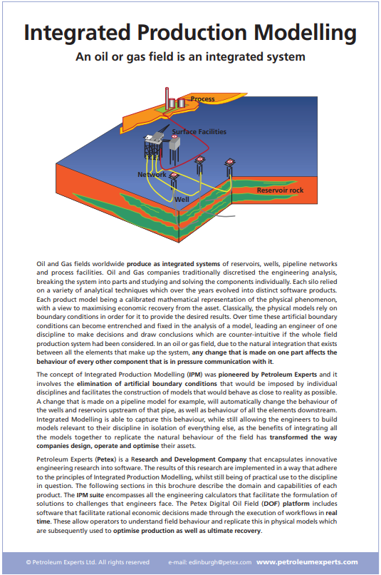
This is an example of Integrated Production Modelling technology please follow link to the vendors website for more information:
Link: Integrated Production Modelling Software for Oil and Gas Fields (petex.com)

